CBS Report  Aka  CBS Medicaid Match | NOTE: THIS IS NOT AN OFFICIAL PROCESS. THIS HAS BEEN CUSTOMIZED SPECIFICALLY FOR App-Dev USE

- Open ASKIT
- Through the main ASKIT screen, select >Tools>Utilities>Batch Update MDC Data> from the drop down menu.
NOTE: this is a count down to zero.
This stored process, PR_GetMDCBatch, deletes all existing records in the CBSPatient table and identifies ASKIT clients to match against the CBS Medicaid data.

  - Open SQL Advantage – login and use KIDNEYPROD
C:\sybase\sqladv-12_5\sqladv.exe

  - Open SyBase Central – login using SA account
C:\sybase\sybcent41\bin\scjview.bat

  - Use the SyBase Central Processes folder to monitor the session ID that is executing the remote i/o match procedure. – this tells me process is running.
NOTE: USE F5 button to refresh screen
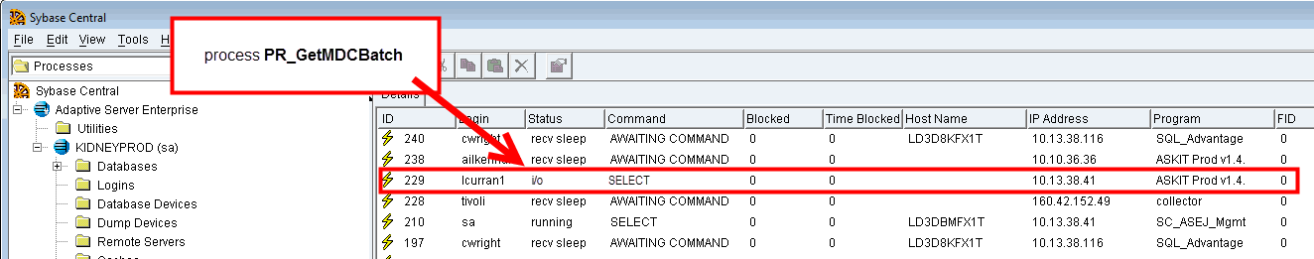
  - In SQL Advantage open script CBSPatient.sql
    - Run select count script
Note: this count will show you the progress of the process.
select count (*) from CBSPatient
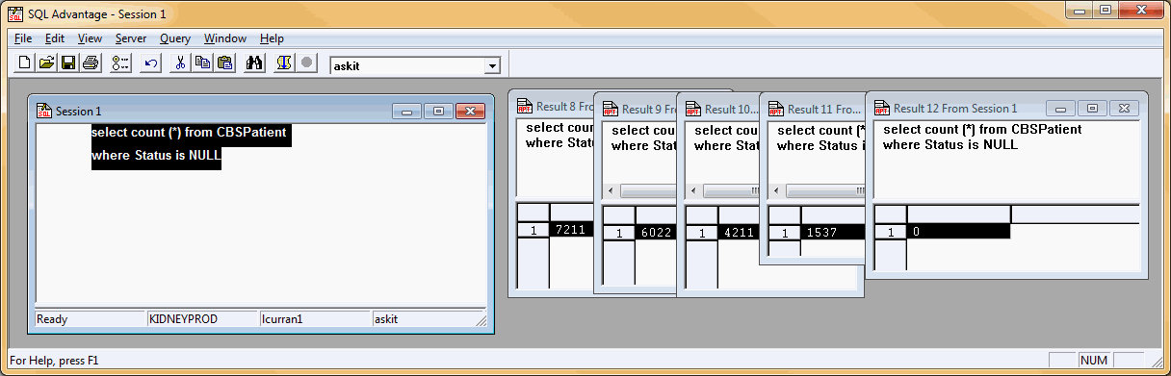
where Status is NULL

  - Monitor process in SQL Advantage by executing the above script regularly. If the count stops, check SyBase Central.
NOTE: Countdown should continue but sometimes gets stuck, especially around 8000
  - If the status displays send sleep instead of remote i/o and the countdown has stalled, kill the session by right clicking the process ID in the Process folder of SyBase Central and selecting delete.
NOTE: You MUST be logged into SyBase using an SA account in order to kill a job.
  - Start the match again through ASKIT. Repeat until there are no NULL values in the Status column of the CBSPatient table. This means the Countdown is ZERO.
NOTE: Countdown will not start over but continue where it left off.
NOTE: Once the countdown is zero, each client record in CBSPatient has a status. Next step begins.

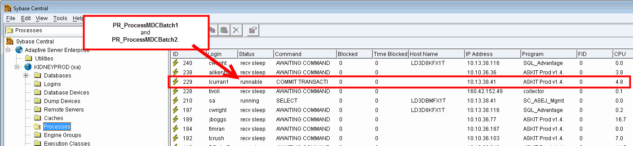
- ASKIT begins updating Medicaid history records for those clients using PR_ProcessMDCBatch1 and PR_ProcessMDCBatch2.

Note: When both processes are complete SyBase Central it will show process status recv sleep and awaiting command.
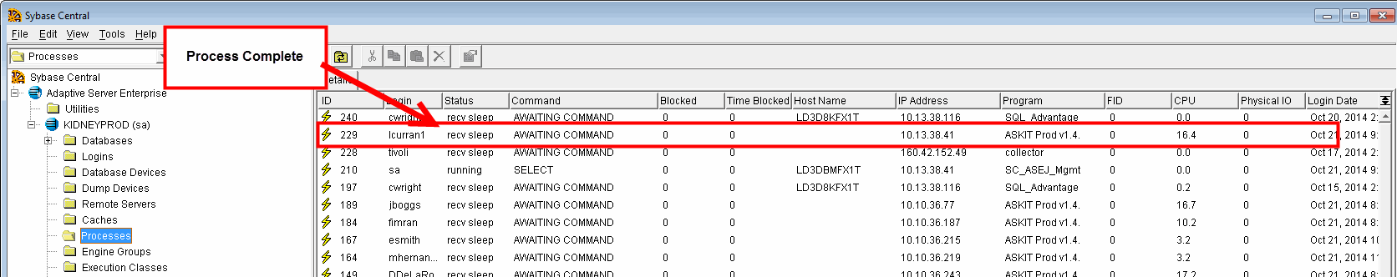
  - Close SyBase but leave SQL Advantage open for the next step

- Open template spreadsheet located in this folder.
\\dshshqctra01\FCHS Share\SHS IT Twices_Kids\
HELPDESK\HD Management\ASKIT\Processes
  - Save as the document in the following manner
Click File
Click Save As
Change path to
\\dshsphsdev1\Automation\AUTOMATION\CBS\CBSMatch\

Change file type to: Excel Workbook (*.xlsx)
Give the file name similar to below replacing the variables (in red) with the actual date.
CBSMedicaidMatch-yyyy-mm-dd.xlsx
NOTE: by using this format (year, month, day) your files will auto sort by name/date, and sort properly. This format can be use anywhere, not just in this folder.

- Run scripts (found at the top of each worksheet tab) in SQL Advantage against the ASKITPROD dbase.
NOTE: Log in as SA.
NOTE: change dropdown from master to ASKIT in SQL Advantage
  - Begin with the left most Tab and work your way right following the steps below.
    - Make any alterations to the script (red text) as advised in the suggestions and examples.
    - Highlight the entire script (framed cells in each tab) and paste into SQL Advantage and execute.
    - Copy and paste the results into the spreadsheet below the script and pre-prepared header rows.
    - Save File and go to the Next Tab repeating these steps (5.1.1 – 5.1.3) until finished
NOTE: The spreadsheet template has examples, highlights and instructions that will help you complete the queries. If you are unsure of what the date should be changed to, you can always open the previous two reports to compare. If you don’t find the previous reports in the save folder then search previous FB tickets for CBS and you should find them there.

- Send Email to the following people. Attach spreadsheet to email.
Jeremy.Triplett@dshs.state.tx.us;
Maria.DeLaCruz@dshs.state.tx.us;
Stephen.Preece@dshs.state.tx.us;
Helpdesk.KHC@dshs.state.tx.us;

CBS Match Reports - DATEHERE
HI,
Please find the enclosed CBS Match Reports. If you have any issues with the reports don't hesitate in contacting me.
Thanks,

- Create FogBugz ticket
Title: CBS Report

Purpose/Open edit: Run CBS Match Report/ MDC Data Update – DATEHERE
Resolved: Copy email and spreadsheet to resolved and close ticket

FINAL NOTE: the scripts and header rows, except for changeable data has been locked to editing. If you must make a change, click Review > Unprotect Sheet. There is no password.

